AutoWeed

# Business Plan

September 15, 2023

# Table of Contents

Executive Summary 4

Introduction 4

Mission 4

Vision 4

Solution Details 5

Description 5

How it Works 5

Key Innovations 6

Business Model and Pricing 7

Market Analysis 8

Customer Profile 8

Customer Problem 8

Solution Benefits 9

Competitive Differentiation 9

Target Market 9

Market Sub-Category and Competition 10

Drone-Based Precision Farming 10

Competitors 11

FarmWise 11

Insitu 12

Iris Automation 12

ModalAI 13

Team 15

Current Team 15

Planned Leadership Structure 15

Other Key Roles 15

Marketing and Sales 17

Go-to-Market Strategy 17

Sales Process 17

Operations 19

KPIs 19

Key Milestones 20

Locations and Facilities 21

Other Operations Considerations 21

Financials 23

3-year Projections 23

Funding 23

Future Strategy 25

Expansion Opportunities 25

Long-term Outcome 25

## Executive Summary

### Introduction

AutoWeed is a pioneering technology platform set to revolutionize the management and control of invasive plant species on large properties. By leveraging the power of advanced drone technology and Artificial Intelligence (AI), we offer a service that accurately identifies, maps and controls plant species in an automated, cost-effective, and highly efficient manner. Through this cutting-edge and innovative subscription model service, we aim to liberate both private landowners and government agencies from the labor-intensive and expensive traditional methods of managing invasive plants. Relying on aerial drones for scouting and mapping, ground-based drones for intervention, and a user-friendly SaaS platform for management and monitoring, AutoWeed ensures a hassle-free approach to ecological management with unparalleled precision and reliability, bringing an entirely new level of ease and efficiency to the challenge of maintaining our natural lands.

### Mission

To empower land stewards in preserving biodiversity by transforming the way we identify and control invasive species through AI and drone technology.

### Vision

By 2030, AutoWeed aims to be the worldwide leader in automated invasive plant control, servicing over 10,000 clients globally and achieving 90% accuracy in plant identification, thereby fostering safer, sustainable ecosystems one property at a time.

## Solution Details

### Description

This business replaces manual labor-intensive identification and management of invasive plants with an automated robot-based service. Provided via a subscription model, private land owners and government land managers will engage us to control invasive species on their properties. Our service will make use of automated ground and aerial drones to identify and control invasive plants. The service will be managed through a custom SaaS platform. We will use off-the-shelf aerial drones, a custom ground-based drone with laser and mechanical control devices, and an AI-powered plant identification system for mapping and identifying plants. Our system will regularly scan client properties aerially, then send in a human driver with ground-based drones if control is needed. This process maximizes profits, minimizes human labor, and minimizes waste, all while providing the most effective control of invasive species.

The SaaS platform will provide our internal teams and our customers with detailed monitoring and alerting data on control activity, scans/maps, scheduling, billing, and more.

One key aspect of launching this business is securing necessary permissions and certifications for drone operations in the locale of service. We'll begin with the US and the FAA.

Risk factors include potential regulatory changes or liabilities associated with drone flight, robot R&D costs, and the accuracy of the AI-based flora identification system. However, we can mitigate these by proactive engagement with the authorities, applying rigid financial discipline, and using an off-the-shelf plant identification library already developed and tweaking it as needed.

### How it Works

The key technical aspects of the service are: an aerial mapping system and a ground-based control system. They will work in tandem to provide an efficient, automated way to manage invasive plant species.

The aerial mapping system uses off-the-shelf drone hardware (e.g. from DJI) equipped with cameras for capturing high-resolution images of property areas. Supplementing this with a machine learning algorithm trained to identify invasive plant species, the AI system will scan, record, map, and analyze the images taken by the drones. This proprietary AI software will act as a “digital botanist” and will be fine-tuned to adapt to regional variances in plant species using locally sourced data and imagery. The AI platform will be hosted in scalable cloud infrastructure.

Once the AI system determines needed treatment areas, our SaaS platform will dispatch a driver with our custom-made ground-based control drone. The ground-based drone will be a specialized, mechanically robust platform (either tracked or multi-leg) with a high-precision laser device and mechanical tools for physical control (e.g., uprooting, cutting). These drones will be overseen by humans during the R&D phase, moving to remote monitoring in full production.

The delivery of the service will be managed through a custom-built SaaS platform. On this platform, customers and internal teams can access the detailed mapping data, review the progress of control activities, schedule sessions, manage billing, and receive reports. The automation of the system allows the platform to serve up regular updates, including pre- and post-control images and progress reports.

### Key Innovations

1. Ground-Based Control Drone Design

2. AI-Powered Flora Identification System Adjustment

3. Custom Built SaaS for Plant Management

Ground-Based Control Drone Design:

The core element of this service will be a ground-based control drone capable of eliminating invasive plant species with precision. Though the idea incorporates off-the-shelf aerial drones, a specialized ground-based drone will need to be engineered. This machinery requires a combination of robust mechanical tools for uprooting and cutting plants, and a laser device. This will demand thorough research and development, with a keen focus on using durable materials that can withstand outdoor conditions. The drone should also have locomotion abilities suited to diverse terrains, accomplished through either a tracked or multi-legged design. Before the design process, we need to determine the physical forces necessary for uprooting various types of invasive plants, which in turn, will guide the creation of an effective mechanical toolset.

AI-Powered Flora Identification System Adjustment:

The business will utilise an AI system modelled on pre-developed plant identification software. However, additional adjustments will be necessary in order to ensure this software can be relied upon to accurately identify specific invasive plant species and work efficiently with the broader system. Therefore, we'll require an AI model trained to recognize the features of invasive species in different regions. This model has to be integrated with a machine learning algorithm trained on a vast dataset of invasive plant images. The fine-tuning and calibration of this model would also require the skills of AI specialists.

Custom Built SaaS for Plant Management:

The service will be delivered and managed through a custom-built SaaS platform. This platform should present detailed mapping data, control activities, session schedules, billing and reporting in an easily digestible format. This will be an intricate process, as it requires the integration of different systems (including drone operational data, AI processing metrics, and customer management tools). It will necessitate cross-discipline software development to build a robust, secure platform that ensures user-friendly access to pertinent information. It will also require careful consideration of UI/UX design principles to provide a comfortable and efficient user experience. The platform must also be scalable, allowing potential growth of both customer base and controlled regions.

### Business Model and Pricing

The business model for AutoWeed is a subscription-based pricing model, designed for ease and robust scalability. AutoWeed provides an end-to-end service, from initial drone detection and mapping, AI-based analysis and identification, through to the controlled physical removal of invasive species using ground drones. This service is driven by a sophisticated SaaS platform that allows for client management, scheduling, billing, and the display of monitoring and alerting data in real-time.

To encompass various sizes and budgets of clients, AutoWeed will offer tiered subscription packages. The tiered pricing approach will be based mainly on the area of land being serviced, to keep it simple and scalable. For instance, a 'Standard' package might cater to a local government managing around 500 acres of land, priced at approximately $5,000 per month inclusive of all features and services. The 'Premium' package could be suitable for larger regions or national parks managing up to 2000 acres, priced at around $15,000 per month. And the 'Enterprise' plan for federal-level clients or large corporations managing vast land parcels, with customizable pricing based on their specific requirements. These prices are not fixed and will be adjusted based on a detailed cost and profit margin analysis. The founder plans for the revenue generated from the subscription sales to fund ongoing R&D, drone hardware, salaries, and market expansion.

## Market Analysis

### Customer Profile

The customer profile for AutoWeed can be primarily divided into two categories: the initial ideal customer profile, which encompasses local/regional government agencies, and the future prospects, consisting of large enterprises and the federal government.

The initial ideal customer profile for AutoWeed is local or regional government bodies that oversee or maintain large areas, particularly those exceeding 500 acres. Invasive plant species constantly affect these entities, making land management a considerable challenge. Such governmental institutions encounter constant labor-intensive manual efforts to identify and control invasive plant species, mounting significant costs towards environmental management and maintenance. Government agencies managing vast land areas, such as parks or nature reserves, are unique customers for AutoWeed due to their increased land stewardship responsibilities and commitment to supporting native biodiversity.

In the future, AutoWeed will extend its service to larger enterprises that manage significant amounts of land and face similar challenges with invasive species. These may include large-scale farming enterprises, forestry companies, and potentially even golf course or resort operators. The decision-makers at these organizations will typically be individuals in senior management or operational roles who are responsible for land management and maintenance. This customer profile is unique due to their dual need for effective land management and cost control.

Additionally, the federal government represents a significant prospective customer. Managing extensive tracts of federal lands, national parks, and protected wildlife areas, the federal government has a vested interest in controlling invasive species to protect native biodiversity. In this scenario, decision-makers will often be Senior Land Managers or Conservation Officers at a federal level.

As AutoWeed expands its operations, valuable opportunities may also arise in providing service to non-profits involved in land conservation and restoration, enhancing the goal of aiding biodiversity preservation. Each customer type provides unique opportunities and challenges based on their specific land management needs and regulatory environments.

### Customer Problem

Local and regional government agencies managing large land areas struggle with constant and labor-intensive manual efforts to identify and control invasive plant species. This lack of efficient means leads to increased spending on environmental management and maintenance while invasive plant species further harm local ecosystems and biodiversity. Furthermore, the systematic monitoring of such vast areas adds to the operational challenges and costs.

### Solution Benefits

With the innovative solution offered by AutoWeed, customers will experience significant cost-savings and increased operational efficiency. The business's AI-enhanced drones will automate the time-consuming task of identifying and controlling invasive plant species on their vast tracts of land, achieving more comprehensive coverage while reducing labor costs. The service's SaaS platform will provide real-time updates on control activities and progress reports, further simplifying the management and decision-making process. Additionally, the ecological benefits of effectively managing invasive species would enhance the agency's environmental stewardship, contributing to healthier local ecosystems and biodiversity.

### Competitive Differentiation

AutoWeed's distinctive competitive advantage lies in its uniquely combined use of aerial drone technology, AI-based plant identification system and a ground-based control drone which differentiates it from its competitors. The high-resolution image capturing and processing abilities of the drones coupled with the elaborate learning model will ensure detailed, accurate, and efficient identification and control of invasive plant species. The inclusion of a mechanical toolset for physical plant control goes beyond the technology and image-based solutions provided by competitors. Further, the model's flexibility to adapt to regional variances underlines AutoWeed's dedication to custom-tailored solutions over a one-size-fits-all approach.

Another highlight of AutoWeed's long-lasting competitive advantage lies in its comprehensive SaaS platform that integrates drone operations, AI processing metrics, and customer management tools. Few competitors have capitalized on such a customer-facing, service managing software, making AutoWeed's platform a significant market differentiator. This platform will not only streamline operations but will also provide customers with an engaging, real-time view of their property, fostering a sense of trust and transparency that will be invaluable in customer retention efforts.

The creation of a specialized ground-based control drone also builds a significant moat for AutoWeed, as it provides a unique robotic solution for addressing invasive weeds.

### Target Market

The target market for AutoWeed falls within the burgeoning "AI in Agriculture" sector, currently valued at around $4.2 billion. This dynamic market is experiencing a robust growth rate of 20.5%, driven by the increasing demand for automation and precision in the agriculture industry. The rise in popularity of drone-based precision farming, a sub-category of AI in Agriculture where AutoWeed will operate, illustrates the trend towards adopting innovative technologies to tackle traditional agricultural challenges in novel ways. Factors fueling this trend include the urgent need for efficient resource management, increasing labor costs, and the drive towards sustainable practices.

However, operating within this market presents a unique set of challenges and opportunities. The target market is largely populated by government agencies who, while they have the financial resources and a genuine need for the solution, may be hesitant to adopt new technologies from a startup company due to potential risks. Furthermore, complying with drone regulations and achieving certification can be a complex and time-consuming process, serving as a significant barrier to entry. On the opportunity side, as the only company offering a specialist service for controlling invasive species using AI and drones, AutoWeed has the potential to carve out a niche within this industry. The increasing focus on protecting biodiversity presents further opportunities, as effective management of invasive species plays a crucial role in preserving and enhancing local ecosystems.

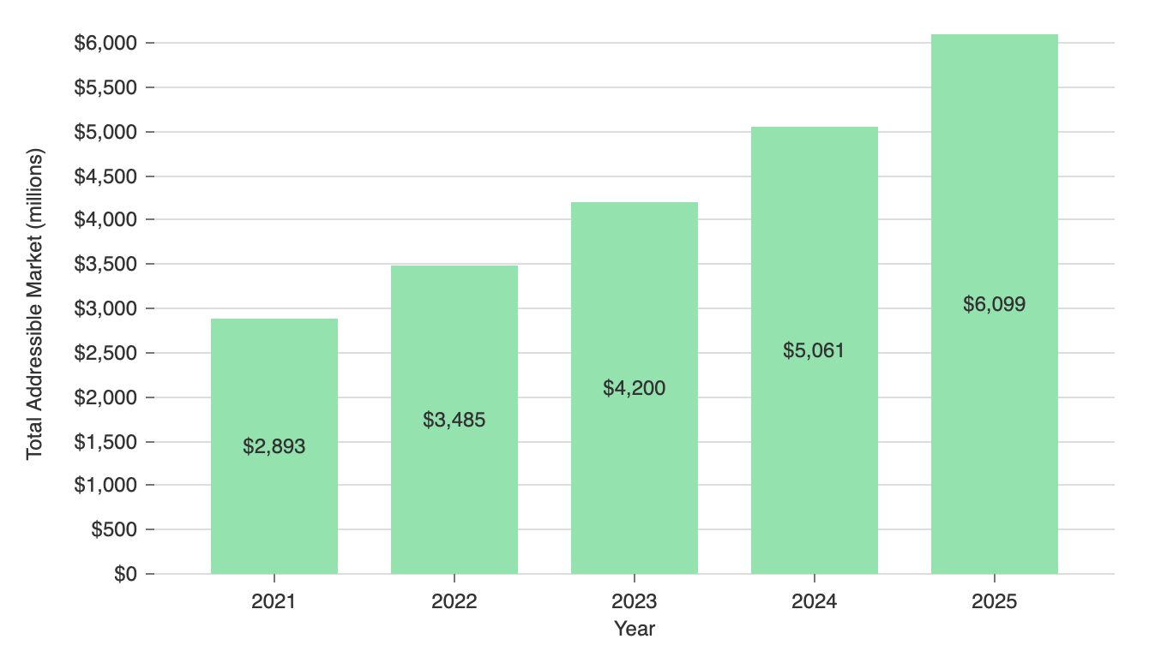

Market Size

Sources:

<https://www.globenewswire.com/en/news-release/2023/02/02/2600582/0/en/Artificial-Intelligence-in-Agriculture-Market-Size-Worth-4-2-Bn-by-2028-AI-in-Agriculture-Industry-Expected-CAGR-25-1-Vantage-Market-Research.html>

<https://www.marketsandmarkets.com/Market-Reports/ai-in-agriculture-market-159957009.html>

### Market Sub-Category and Competition

#### Drone-Based Precision Farming

##### Competitors

The following section provides details on each notable competitor.

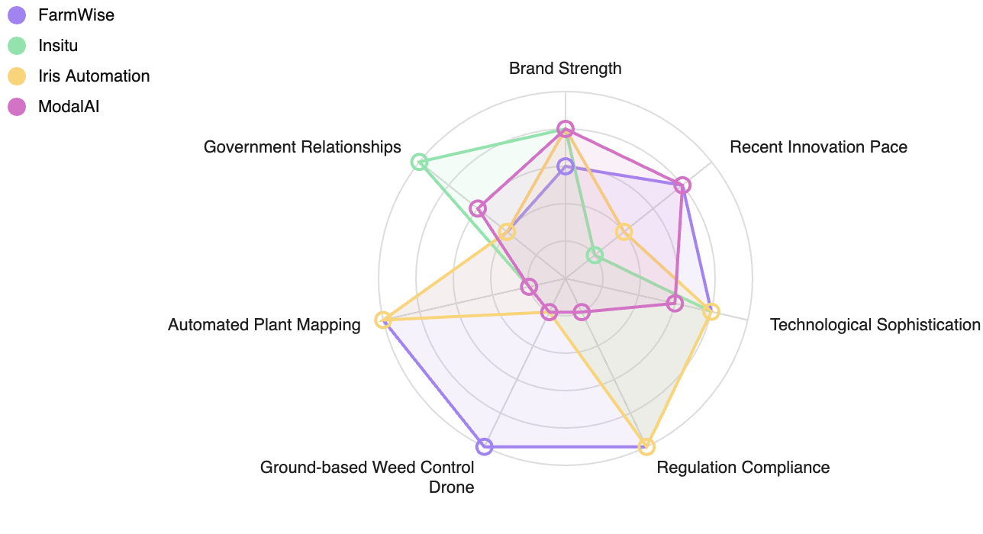

Competitor Strengths and Weaknesses

##### FarmWise

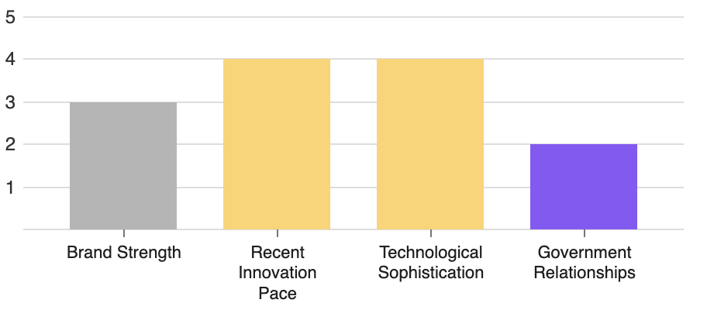

**✓** Regulation Compliance

**✓** Ground-based Weed Control Drone

**✓** Automated Plant Mapping

FarmWise provides a precision weeding implement named Vulcan, equipped with advanced computer vision systems and machine learning software. Their solution offers high accuracy, ease of use, compatibility with industry-standard tractors and can handle diverse crop lines. They also offer continuous software updates and on/off-field support for users.

* **Business Model:** FarmWise's business model appears to be product sale focussed, offering their Vulcan system for pre-order, along with continuous software updates and support services.
* **Ideal Customer Profile:** FarmWise targets farmers and agriculture operations seeking efficient, precise, and automated weeding solutions.
* **Unique Selling Proposition:** FarmWise offers a high-precision, machine learning-based weeding solution that reduces the need for manual labor and enhances operational efficiency.

##### Insitu

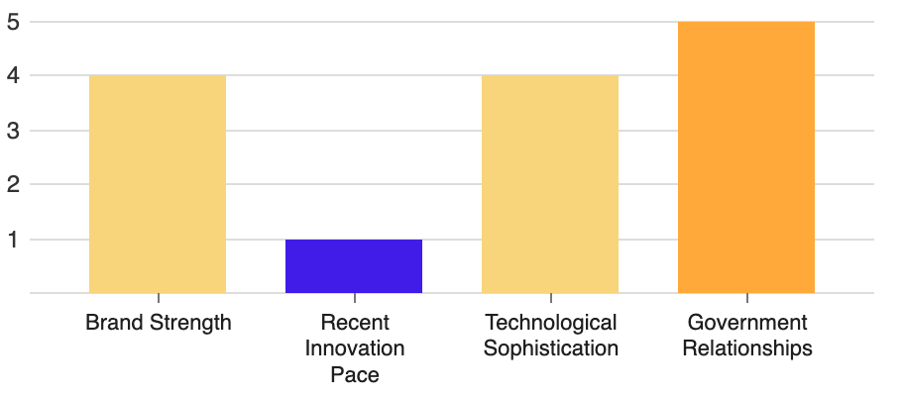

**✓** Regulation Compliance

**✗** Ground-based Weed Control Drone

**✗** Automated Plant Mapping

Insitu is an established entity producing unmanned systems with a range of features, which could compete with the AI and drone system being proposed. Their systems are backed by 1.3 million hours of real-world operational experience in harsh environments. While the primary focus seems to be defense and government, the technology behind their product may be utilized in identifying and managing invasive plant species.

* **Business Model:** Insitu sells a suite of unmanned systems to government clients in need of surveillance and intelligence data, selling both the hardware and software necessary for operation.
* **Ideal Customer Profile:** Insitu targets defense and government clients with a need for intelligence gathering and surveillance.
* **Unique Selling Proposition:** Insitu Unmanned Systems provide valuable intelligence and surveillance data in real-time, backed by extensive operational experience.

##### Iris Automation

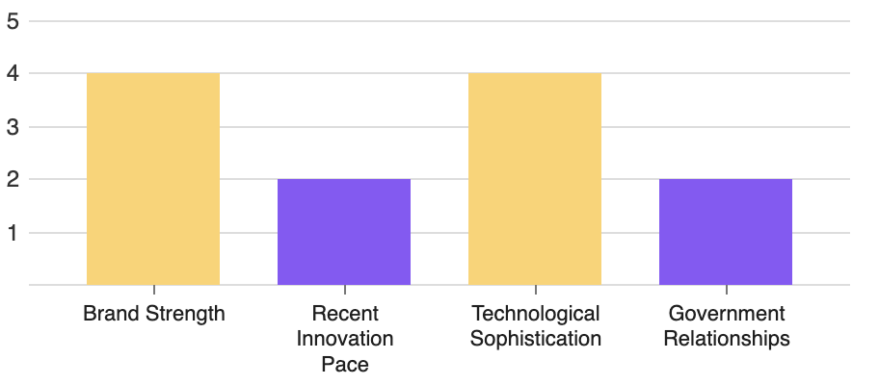

**✓** Regulation Compliance

**✗** Ground-based Weed Control Drone

**✓** Automated Plant Mapping

Iris Automation provides forestry management solutions via drone & AI technology, similar to Automated Invasive Plant Management. They are focused on forest surveillance, identifying changes over time due to various factors, including invasive species. Iris Automation offers advanced drone capabilities, such as Beyond Visual Line of Sight (BVLOS) that provides significant strategic advantage in dense forest surveillance. This technology might potentially compete with and challenge the business idea.

* **Business Model:** Iris Automation mainly operates by selling drone-based forest management solutions to forestry organizations with a particular focus on surveillance.
* **Ideal Customer Profile:** Forestry organizations and providers struggling with forest management and surveillance, particularly those dealing with large land area and resource constraints.
* **Unique Selling Proposition:** A leading provider of drone technology enabling forest topography tracking and surveillance, including BVLOS capabilities for efficient forest management.

##### ModalAI

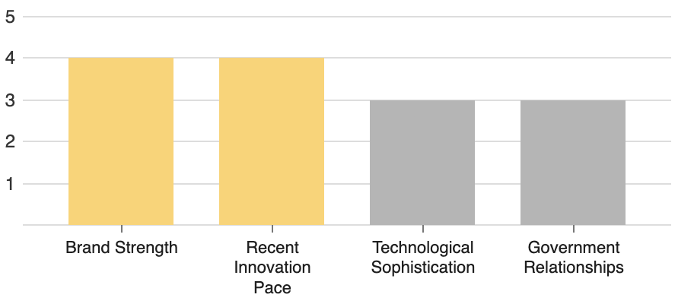

**✗** Regulation Compliance

**✗** Ground-based Weed Control Drone

**✗** Automated Plant Mapping

ModalAI operates in the drone field focusing on AI-driven solutions. They offer advanced technology products including autonomous flight controllers and autopilot systems. Key to their offer is a light-weight powerful companion computer which enables smaller, smarter, and safer drones and robots to operate on 4G and 5G cellular networks. Although not directly in competition with the invasive plant management concept, the autonomous flight and spotting application potential of their technology ensures they remain competitive.

* **Business Model:** ModalAI's business model appears to revolve around the sale of their drone technology, including autopilots, flight controllers, and development kits.
* **Ideal Customer Profile:** Their ideal customer profile seems to be developers, manufacturers and businesses seeking advanced drone technology for a range of applications.
* **Unique Selling Proposition:** Their unique selling proposition is their sophisticated AI-powered drone technology, enabling autonomous operation and communications across 4G and 5G networks.

## Team

### Current Team

The current team consists of the founder and CEO, John Smith. His background in leading a prior venture-backed company from 0 to 100 team members and $20MM in ARR positions him well for success in this business. John has extensive technical expertise in SaaS, and manages a 30-acre forestry property.

### Planned Leadership Structure

The AutoWeed leadership structure will be lean and focused, designed to navigate the crucial early years of operation while providing the necessary flexibility for scaling as the business grows. Initially, the team will comprise four key roles.

The CEO, currently the founder, will guide overall strategy, build investor relations, and lead team development. A Chief Technology Officer (CTO) will be hired to oversee the refinement and development of the software, AI, and drone technology crucial to AutoWeed's operation. The CTO will also work closely with the CEO to steer the technological vision of the business.

A Director of Operations will manage the day-to-day business operations, including human resources, customer service, and the maintenance of drone hardware. The Operations Director will be responsible for ensuring seamless coordination between the various arms of the business for efficient service delivery.

A Head of Business Development will be tasked with securing new contracts, fostering relationships with potential and existing customers, and exploring opportunities to expand the business both geographically and into new customer segments.

As AutoWeed grows, it plans to expand the leadership team as required. For instance, it might eventually need directors or VPs for specific segments such as government relations or drone operations to address unique challenges and advancements. However, in the early years, this leadership structure aims to efficiently utilize capital and ensure the focus remains on the core operation, which is the innovative technology platform and customer satisfaction.

### Other Key Roles

Two additional key roles will be crucial in the first years of AutoWeed's operation: a Lead Robotics Engineer (LRE) and a Regulatory Compliance Specialist (RCS).

The LRE will be responsible for overseeing the development, prototyping, testing, and enhancements of the ground-based control drone. This role is key as the efficacy and reliability of the control drones are critical to the product's functionality and the solution AutoWeed offers. The LRE will also need to troubleshoot issues with the drones, perform maintenance, and recommend improvements to ensure optimal performance. Given the specific nature of the role, the search for an LRE will focus on professionals with a strong background in robotics, mechanical engineering, and experience in working with drones. Networking at industry events, tapping into relevant online communities, and leveraging connections from universities known for robust robotics programs will be key components of the recruitment strategy.

The RCS will be in charge of obtaining and maintaining any necessary permits or licenses to operate the drone technology in compliance with state and federal regulations, particularly in regards to the Federal Aviation Administration (FAA) in the United States. Since regulatory bodies often have different rules that apply to various industries, the RCS will need a comprehensive understanding of those specific to drone technology, agriculture, and environmental management. They will also be responsible for keeping the company updates on any regulatory changes that may impact the AutoWeed business model. This role is unusual and vital because it directly affects the legality of our operations and consequently, our ability to provide services to customers. For hiring the RCS, the business will look for professionals with experience in aviation and environmental law, as well as proficiency in compliance issues in tech-driven industries. The recruiting process will leverage professional networks, online job boards focused on legal professionals, and partnerships with law schools.

## Marketing and Sales

### Go-to-Market Strategy

With the rise in the use of drones and AI technology in environmental management, AutoWeed's go-to-market strategy will focus on gaining early market traction by creating awareness about its revolutionary service, establishing credibility, and securing key relationships across the public and private sectors.

To establish the AutoWeed brand, the business will focus on thought leadership. It will publish informative articles, whitepapers, and case studies on the application of AI in agriculture and drone-based precision farming. These materials will highlight AutoWeed's competitive edge and the benefits of its service, with a clear focus on the efficiencies, cost savings, and ecological impact possible through its automated invasive plant control solution. By participating in industry conferences and seminars, the business will also position itself as an innovative player in this niche market. Further, the business will employ SEO strategies to maximize its online presence, and use targeted social media marketing campaigns to target decision-makers in government bodies and large landowning enterprises.

In the realm of sales, AutoWeed will use an Enterprise Sales approach to strategically target local and regional government agencies, its identified launch customers. A dedicated sales team will be tasked with identifying potential leads, initiating strategic conversations and demonstrating the efficacy and benefits of the AutoWeed solution. To expedite customer acquisition, AutoWeed will leverage the founder's network of forestry property owners and suppliers. The sales cycle will likely be longer in this model given the nature of government procurement processes, hence the prioritization of building strong relationships and thought leadership to facilitate sales.

Moreover, for customer retention and expansion, AutoWeed will strive to consistently deliver quality service, regular client communication, and seamless user experience. Specialized account managers will be assigned to understand and cater to individual client needs, anticipate future requirements, and maintain client satisfaction.

AutoWeed also intents to establish strategic alliances with drone manufacturers, AI technology developers, and other key players in the agri-tech industry. These alliances, coupled with tailored customer referral programs, will further aid in AutoWeed's market penetration and its broader goal of becoming a worldwide leader in automated invasive plant control.

### Sales Process

The initial step in the AutoWeed's sales process will involve identifying appropriate leads within local and regional government agencies. The company will use targeted data mining techniques, leveraging online platforms and databases such as D&B Hoovers, ZoomInfo or LinkedIn to find contact details of the key decision-makers including Land Managers and Soil and Water Conservation Officers.

Upon identifying these leads, the sales team will engage in a meticulous process of outreach and follow-up. This outreach will most likely take the form of personalized emails and phone calls, designed to articulate the benefits and operational efficiencies brought about by AutoWeed's innovative service. As part of this outreach, the sales team will leverage the informative articles, whitepapers, and case studies created as part of AutoWeed's thought leadership strategy. Moreover, they'll use CRM systems such as Salesforce to manage leads, track communication and ensure timely follow-ups.

Following the initial outreach, the sales team will aim to schedule demos and presentations with potential clients to showcase the efficacy of AutoWeed's solution and platform. This step will focus on demonstrating the immense value— both operationally and ecologically— that the solution brings, including cost savings, comprehensive coverage, and increased biodiversity. The sales team would do well to train specifically for robust virtual demos given the increasing prevalence of digital meetings.

During these demos, prospective customers will be given a detailed walk-through of the SaaS platform, demonstrating the ease of scheduling sessions, receiving real-time reports, and managing overall operations. In time, as the team grows and the customer base expands, localized sales teams could provide on-site demos using the actual drones, offering potential clients a tangible feel of the platform's capabilities.

As the discussions progress, the sales team would negotiate contractual terms, aiming to close with a pilot project. This pilot phase will allow customers a risk-free opportunity to assess the effectiveness of AutoWeed's solution on a smaller tract of land. The success of these pilots will fuel expansion within that client organization and serve as a case for other potential customers.

In the future, as the business scales, the sales team will need to expand and specialize, with dedicated sales representatives catering to specific segments such as local governments, regional agencies, and eventually, large enterprises and federal bodies. This specialization will facilitate a more customized and effective sales process as AutoWeed grows.

## Operations

### KPIs

AutoWeed understands the importance of tracking Key Performance Indicators (KPIs), as they provide actionable insights to guide its operations, measure its progress towards strategic goals, and drive overall business growth. These KPIs are carefully selected based on the specific nature of the business, its overarching objectives, and its distinctive market environment. The initial years of operation will focus primarily on establishing a solid customer base, refining its technology, and scaling its operations. Therefore, the primary KPIs will reflect these focal areas:

1. Customer Acquisition Cost (CAC): This metric tells how much the business spends to acquire a new customer. It will include marketing expenses, sales team salaries, and other associated costs divided by the number of new customers. Lowering the CAC is key to improving profitability and should decrease over time with effective marketing and reputation building.

2. Monthly Recurring Revenue (MRR): This is a measure of the predictable revenue the business can count on every month, essential for a subscription-based business. Tracking this KPI will help assess the financial health and cash flow stability of AutoWeed.

3. Customer Retention Rate: Given AutoWeed's subscription-based model, retaining customers is equally, if not more important, than acquiring new ones. This KPI measures the number of customers who continue to subscribe to the service over a specific timeframe. Higher rates indicate customer satisfaction with the product and service.

4. Usage of Serviced Land (in acres): This KPI indicates the amount of land serviced by AutoWeed's system, reflecting how well the business is scaling and how effectively the technology is being implemented.

5. Accuracy of AI Plant Identification: This is a measure of the AI system's ability to correctly identify invasive plant species. A high accuracy is key to the credibility of AutoWeed and will directly enhance customer satisfaction and environmental impact.

6. Number of Strategic Partnerships: This KPI measures the number of alliances established with drone manufacturers, AI technology developers, and other partners. It's a leading indicator of market traction and can accelerate AutoWeed's growth and market penetration.

7. Software Uptime: The availability of AutoWeed’s SaaS platform is critical to customer satisfaction, especially when downtime can impact drone missions and customer service.

8. Churn rate: This KPI tracks the number of customers who cancel their subscription each month. A lower churn rate indicates higher customer satisfaction and the effectiveness of retention strategies.

9. Customer Satisfaction Score (CSAT): This measures the satisfaction of customers with AutoWeed's service and platform. A high CSAT score would reflect well on AutoWeed's customer experience.

10. Operational Efficiency: This is measured by the ratio of operational costs (drone maintenance, manpower, etc.) to the number of active subscriptions. A decrease in this ratio over time would suggest increasing operational efficiency.

Each of these KPIs will be tracked using the business's internal data, customer feedback, and competitive benchmarks, analyzed regularly, and used for informed decision-making and strategy optimization.

### Key Milestones

The team aims to hit significant milestones within the first couple of years, paving the way for sustainable and scaled operations. The early establishment of these milestones provides a stable framework for the business to follow as it grows and evolves as an industry leader in automated invasive plant control.

1. Develop Prototype AutoWeed System: Within the first year, the business will focus on developing and testing a prototype AutoWeed system, including a functioning AI plant identification model, operational aerial and ground drones, and a beta version of the SaaS platform. This milestone is essential as it demonstrates to potential customers and investors that the primary functionality of the product is viable and effective.

2. Secure First Contract with Local Government: The COVID-19 pandemic has left many local governments keen to explore low-cost solutions that can help manage their natural resources. By month 18, AutoWeed plans to secure its first contract with a local government agency. This milestone is crucial as it not only provides a steady stream of revenue but also serves as proof of concept that the business can attract and service customers in its target market.

3. Achieve 90%+ Accuracy in Plant Identification: By the end of the second year, the goal is for the AI system to achieve over 90% accuracy in identifying invasive plant species. This is a key milestone as it validates the effectiveness of the technology and provides a strong selling point to prospective customers.

4. Expand to 5000 Acres of Serviced Land: By the end of the third year, the business aims to service a cumulative total of 5000 acres of client properties. This measure of scale is critical in demonstrating the business's capacity to handle the demands of growing customer base and increases in operation area. This milestone creates trust in our scalability and operational efficiency.

Each of these milestones helps to validate the AutoWeed solution and demonstrate the progress being made in fulfilling the business's vision. They indicate that the business is providing valuable and practical solutions to real-world problems and keeps the company on track towards its primary goal: to be a worldwide leader in automated invasive plant control.

### Locations and Facilities

In the first year, AutoWeed will operate from a modest office space in the Portland, OR metro area. The Portland area has easy access to transportation and a talent pool of individuals skilled in software development. The office will house the management team, the sales team, and the technical team that includes the AI and drone specialists. The workspace will be equipped with the necessary infrastructure for software and hardware development and will serve as a center for customer service, business development, and operations management. The office will include a secure storage area for drone hardware.

During year 2, AutoWeed plans to lease a larger office space to accommodate the growing team, especially as the company starts to build more specialized roles. Given the nature of the service, AutoWeed will need temporary fieldwork facilities near the client locations. These could be mobile command centers such as RVs, being used for drone operations wherever AutoWeed services are required. These mobile command centers will be equipped with charging stations for drones, spare parts, and laptops for the field team to monitor and control drone activities.

As the business scales and expands into different territories and countries, the company may need to establish local operations hubs. These hubs would be used to manage regional sales and provide localized ground drone operations, alongside a network of service and maintenance facilities to keep the drone fleet running smoothly.

### Other Operations Considerations

In the early stages, an essential operations consideration for AutoWeed will be to source highly technologically skilled team members. Specialized technicians and engineers are required to handle and maintain the advanced drone technology, develop and fine-tune the AI-based system, and manage the SaaS platform.

A unique supply chain element in AutoWeed's operations is the use of off-the-shelf drones. While this allows for a cost-effective and readily available solution, it also means that AutoWeed will be dependent on external manufacturers for some key operational hardware. Aligning delivery times with customer needs and the servicing schedule will be critical. Proactive relationship management with suppliers and a well-organized procurement plan will be essential to ensure smooth operations.

In the long run, as AutoWeed expands its service area and increases client base, it will necessitate a robust logistics plan. The servicing drones will need to be transported securely and efficiently from one client site to another, which will require a well-routed transport strategy, ensuring minimal downtime and maximum productivity.

## Financials

### 3-year Projections

|  |  |  |  |
| --- | --- | --- | --- |
|  | **2024** | **2025** | **2026** |
| **Revenue** | $120,000 | $1,800,000 | $3,800,000 |
| **COGS** | $50,000 | $720,000 | $1,520,000 |
| **Gross Profit** | $70,000 | $1,080,000 | $2,280,000 |
| **Gross Margin** | 58.3% | 60.0% | 60.0% |
| **Operating Expenses** | $490,000 | $960,000 | $1,200,000 |
| **Operating Profit** | -$420,000 | $120,000 | $1,080,000 |
| **Capital Expenditures** | $2,000,000 | $500,000 | $400,000 |
| **Investment Income** | $3,000,000 | $500,000 | $0 |
| **Ending Cash Balance** | $5,500,000 | $5,200,000 | $5,880,000 |
| **Team Members** | 5 | 8 | 12 |

AutoWeed's revenue is expected to increase gradually, commencing from the second half of 2024 following the successful contract with an initial government customer. To cater to more customers, we'll expand the team as our service area increases, which translates to a rise in operating expenses. Some costs of goods sold, such as drone maintenance and cloud computing expenses for the SaaS platform, will be correlated to the service area. The initial capex is significant due to the purchase of high-end drones and the development of proprietary AI and SaaS systems - which are all key to delivering the solution. Additional capex will be needed in the first three years mostly for hardware upgrades and related technological enhancements. The venture anticipates initial funding of $3 million to cater to these costs. By 2026, the business should be self-sustaining financially while servicing thousands of acres with an expanding customer base.

### Funding

The business will pursue a comprehensive funding strategy that balances cautious growth with sufficient capital to execute on the ambitious vision. It is anticipated that AutoWeed will raise around $3 million during the initial phase of the business. This will primarily be sourced from venture capitalists and angel investors within the founder's network who understand the unique needs and growth trajectory of a service-oriented, technology-driven venture.

Using these funds, the business will acquire the necessary drone technology, develop the AI and SaaS platform, and deliver the first working version of the system to the initial government customer. Securing this initial funding will also enable AutoWeed to set the operational infrastructure running, hire the necessary team members, and adequately market the service to prospective customers.

After it starts generating revenue, AutoWeed will aim to become mostly self-funded through revenue from its subscription sales. The business will also explore government grants related to environmental conservation and technology innovation. When AutoWeed is more established and has proven its model, further speedier expansion may be funded in part by series B and C investment rounds, as necessary, to take the global market opportunity fast and become the market leader. These funds will finance customer acquisition, potential land expansion, research and development, marketing, and team growth.

## Future Strategy

### Expansion Opportunities

Once the business has firmly established its innovative service within the local and regional government sector, there are several potential avenues for further expansion. The federal government, with vast tracts of national parks and other lands under its manage, represents a significant market segment waiting to be tapped. AutoWeed's solution could be invaluable in assisting federal authorities in maintaining biodiversity on these lands. Beyond the government sector, large private landowners such as forestry companies, agribusinesses, or conservation organizations could be strong prospective clients. Offering tailored services for diverse landscapes could become a new revenue stream.

Another significant expansion opportunity lies in broadening AutoWeed's geographic reach. While the initial focus will be on penetrating the US market, there is substantial potential overseas, particularly in countries like Australia and New Zealand, where invasive species have posed significant ecological problems. The business would need to navigate diverse regulatory environments and potentially partner with local entities for successful expansion.

Further growth could also come from expanding the product offering to include additional services related to land conservation and biodiversity enhancement. For example, after eradicating invasive species, AutoWeed could consider introducing an offering for the reestablishment of native plant species. With its extensive collected data, the business may also branch into providing critical environmental insights and analytics to conservationists, researchers, and policy-makers, thereby contributing even more significantly to global biodiversity efforts.

### Long-term Outcome

The long-term outcome plan for AutoWeed envisions establishing itself as a global leader in automated plant recognition and control, ultimately culminating in a lucrative sale to a strategic acquirer. This outcome will ensure consistent and sustainable growth, while maximizing the venture's value for its stakeholders.

Given AutoWeed's unique position straddling technology, agriculture, and environmental conservation sectors, the business presents a compelling acquisition target for various types of companies. Tech giants, especially those with existing investments in AI, cloud computing or drone technology, could be attracted by AutoWeed's sophisticated software and substantial data banks. Examples of potential acquirers might include Amazon, Google, or Microsoft, that have shown interest in agricultural tech applications.

On the other hand, agricultural or forestry corporations may be interested in AutoWeed's advanced approach to plant management. Having honed its technologies in line with the stringent requirements of government contracts, AutoWeed could be advantageous for a company like John Deere, Kubota, or even Monsanto, looking to augment its plantation and pest management offerings.

Finally, environmental conservation organizations may find AutoWeed's AI and drone-based invasive plant control technology a great addition to their toolset in curbing biodiversity loss. Large NGOs or bigger conservation trusts could be potential buyers.

All said, multiple strategic outcomes should be available to AutoWeed, maximizing returns to the stakeholders.